Are you covered?
Homeowners policies do not cover flood and water damage losses.

To learn about the National Flood Insurance Program (NFIP) and about obtaining coverage, visit www.floodsmart.gov.
- Flood and earthquake damages are not covered by basic homeowners and other residential policies. Earthquake coverage is available in some areas as a special add-on to your homeowners insurance.

- If you have flood insurance through the National Flood Insurance Program (NFIP), your adjuster may be able to assist you in coordinating your claim or you may visit its website at www.fema.gov/national-flood- insurance-program.

- Be sure to review your insurance policy each year to make sure coverage is adequate.

- Visit the Department of Insurance website at www.doi.nebraska.gov to view more consumer alerts and obtain brochures on weather-related insurance matters.

How the Department can help

The Nebraska Department of Insurance is available to offer assistance in the following situations:

- Your agent or company doesn’t respond to
your calls.

- You believe you have not received a fair settlement.

- You have a question or dispute about contract language or state legal requirements for coverage.

Toll-Free Consumer Hotline:
1-877-564-7323, option #1
(connects to a property/casualty investigator)

G o o d L i f e . G r e a t O p p or t u n i ty .
DEPARTMENT OF INSURANCE
PO Box 82089
Lincoln, NE 68501-2089
Toll-free hotline: 1-877-564-7323 Local phone: 402-471-2201 www.doi.nebraska.gov

After the Storm—
The Disaster Claims Process

What to Expect When Your Home is Damaged

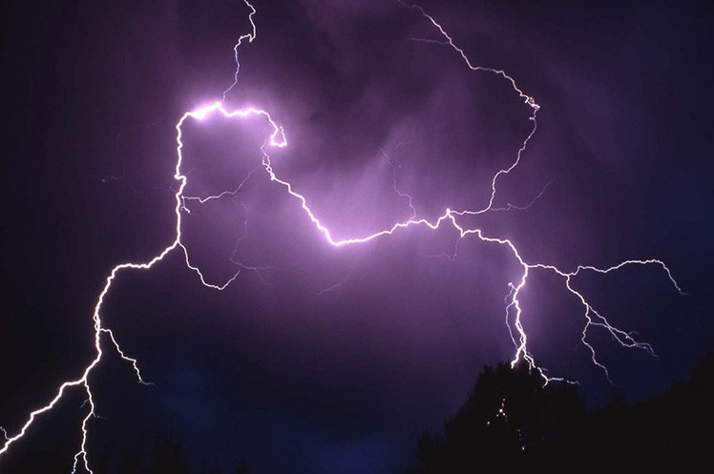
Information provided by
Nebraska Department of Insurance

OUT16291 - Rev. 03/18

Immediately Following the
Disaster
- Contact your insurance agent or your insurance company as soon as possible. Keep a record of the time, date, topic and name of person you talk to every time you call. You may also visit the Department’s website or call the consumer hotline for a list of home office claim numbers.
- Make temporary repairs needed to prevent further damage. For example, use a tarp or other material to cover a hole in the roof or to cover a broken car window to keep out rain. Otherwise, further damage will likely not be covered by insurance.
- Don't make permanent repairs until your insurance company has inspected the damage. If you do, your claim might be denied.
- Do not dispose of property until an insurance adjuster has reviewed it for your claim and has given the approval to do so.
- Keep receipts for materials you buy so you can be reimbursed.
- Survey the damage and take pictures.
- Make a list of all personal property destroyed or damaged. Note the date, price and place of purchase and attach any sales receipt you have. The adjuster will request this information.
- If you do not have a home inventory, begin making a list of destroyed, damaged or missing items going room-to-room by memory,, including as much detail as possible. A home inventory spreadsheet will assist you in listing the items found. A home inventory spreadsheet can be found on the Department’s website, or you can download a free NAIC app for iPhone® at myHOME Scr.APP.book.
- Ask your insurance agent or company if your policy covers living expenses until repairs are made to your home. Many homeowners policies provide for temporary lodging and meal expenses up to 20 percent of the insured value of your home, if it is damaged.
- Be sure you are present and watch when contractors inspect your home. Some unscrupulous companies will cause damage to drive up the repair cost, and your insurance company will likely not cover the additional cost. Tip: Visit the Nebraska Department of Labor website at dol.nebraska.gov for tips on how to choose a contractor.
- Public adjusters may offer to assist but will charge a fee—generally a percentage of your benefit— for their services.
- If a public adjuster assists, check to be sure the public adjuster is licensed as a consultant with the Department. Be sure to ask for references and qualifications before retaining a public adjuster.
- The adjuster may ask you for a list of all damaged property with the date, price and place of purchase. Keep a copy of the list and all insurance company forms you fill out.

- Once your claim is processed, get estimates from contractors or auto repair shops known to you or recommended by someone you trust.

- Don't pay the whole repair bill in advance. Pay in full only when the work is completed according to your agreement.

- Do not feel rushed or pushed to agree on a settlement. If there are disagreements, try to resolve them with your insurer. If you cannot reach an agreement, we can help you decide if arbitration or mediation is an option.

- Your full claim may come in multiple payments. The first will likely be an emergency advance and may include additional living expenses. The payment for your personal property and any additional living expenses will be made out to you. Payments for the structure may be payable to you and your lienholder if there is a mortgage on your home. Lenders may place that money in an escrow account to pay for repairs as the work is completed.

